CSA0501-DATABASE MANAGEMENT SYSTEMS
LAB EXPERIMENTS DATE:21/08/2026
NAME:K.SARANYA(192424409)

EXPERIMENT 13 -- Simple Programming using CASE and LOOP

AIM:
To learn how to use MySQL CASE and LOOP statements to execute a block of code repeatedly based on a condition in the Flight Reservation System database.

PROCEDURE:
The CASE statement provides conditional execution similar to IF-THEN-ELSE. The LOOP statement repeatedly executes a set of statements until it is terminated using LEAVE.

CASE Syntax:
CASE case_value
WHEN when_value THEN statement_list
[WHEN when_value THEN statement_list] ...
[ELSE statement_list]
END CASE;

LOOP Syntax:
[begin_label:] LOOP
statement_list
END LOOP [end_label];

PROGRAM:
Program – 1 (CASE)
Classify a ticket amount as Low, Average or High.
DELIMITER //
CREATE FUNCTION Ticket_Level(monthly_value DECIMAL(10,2))
RETURNS VARCHAR(20)
DETERMINISTIC
BEGIN
DECLARE income_level VARCHAR(20);
CASE
WHEN monthly_value <= 4000 THEN
SET income_level = 'Low Income';
WHEN monthly_value <= 5000 THEN
SET income_level = 'Avg Income';
ELSE
SET income_level = 'High Income';
END CASE;
RETURN income_level;
END //
DELIMITER ;
SELECT Ticket_Level(4500) AS Income_Level;
OUTPUT:
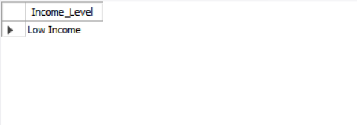

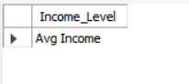

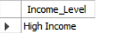

Program – 2 (LOOP with ITERATE)
Increase the ticket amount while it is less than 4000.
DELIMITER //
CREATE FUNCTION Increase_Amount()
RETURNS DECIMAL(10,2)
DETERMINISTIC
BEGIN
DECLARE income DECIMAL(10,2) DEFAULT 1000;
amount_loop: LOOP
SET income = income + 500;
IF income < 4000 THEN
ITERATE amount_loop;
END IF;
LEAVE amount_loop;
END LOOP amount_loop;
RETURN income;
END //
DELIMITER ;
SELECT Increase_Amount() AS Final_Amount;
OUTPUT:
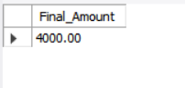

RESULT:
Thus the Simple programming exercise using CASE and LOOP was successfully executed in the Flight Reservation System database.

